Quarch Technology Ltd

Application Note – AN-006

Python Control of Quarch Modules

For use with:

**Any Quarch module**

**QuarchPy Python Libraries**

Tuesday, 24 April 2018

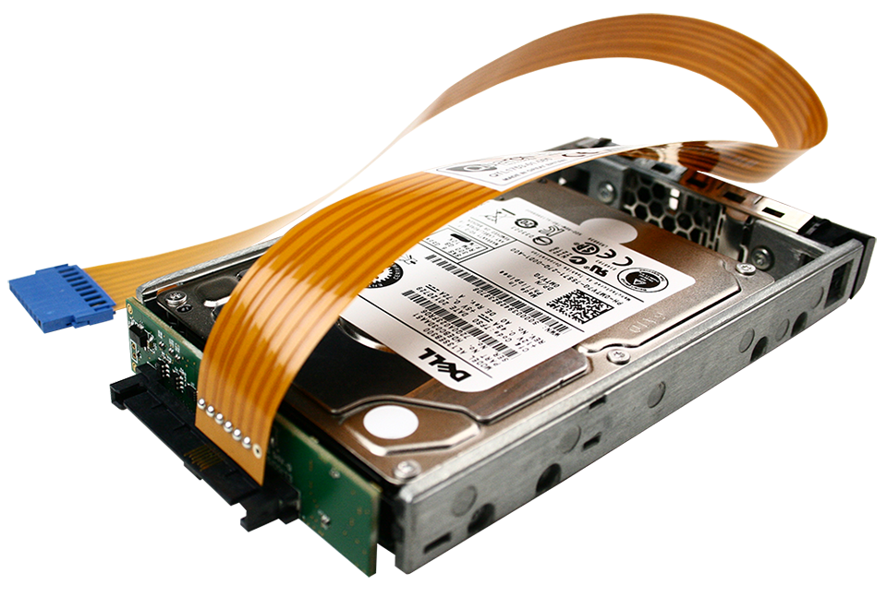

# Change History

|  |  |  |
| --- | --- | --- |
| 1.0 |  | Initial Release |
| 1.1 |  | Added ReST control option |
| 1.2 |  | Improved ReST control (escaping special characters)  Added Array Controller example |
| 1.3 |  | Added details for CentOS setup |
| 1.4 | April 2018 | Major changes, now uses PIP installed library  Greatly simplifies install and version control |

Contents

Change History 2

Introduction 4

Modules Supported 4

Requirements 4

Application Note Example Files 4

Install Components 5

Quarch USB Driver install 5

Python install 5

QuarchPy library install 5

Setting up to run the examples 7

Linux USB Permissions 7

Hardware Setup 8

Selecting the connection type 8

Selecting the example to run 9

Test description 10

# Introduction

Quarch modules can be easily controlled using Python and a USB, Serial or LAN connections.

This application note provides a number of simple examples, showing how to connect to and automate control of our products.

This application note (as of 1.4) makes use of the QuarchPy python library. This is a break from the previous versions, but is far easier to install and upgrade than previous versions.

## Modules Supported

All standard Quarch modules, which support LAN, Serial or USB interfaces

## Requirements

* 1. Install Quarch Torridon USB Drivers (if using Windows)
  2. Install Python 2.x or 3.x
  3. Install QuarchPy Library

## Application Note Example Files

The **AN-006 - Python Control of Quarch Modules.zip** should be extracted to your preferred location.

**Python Control Examples.py**This file contains a number of simple python examples, which can be enabled/disabled by commenting out the relevant lines.

**QuarchPy Library**  
This library is required to run all Quarch Python examples and download instructions for it are later in this document

# Install Components

## Quarch USB Driver install

For windows, if you want to use USB control of modules, install the Torridon USB driver:

<https://quarch.com/file/torridon-driver-win8>

Download the file, extract and run the correct installer for your system.

## Python install

If you do not already have Python installed, download and install it from:

<https://www.python.org/downloads/>

Under Windows it is helpful to make sure the Python installation directory and PythonXX\Scripts are included in the PATH environment variable. See:

<https://docs.python.org/2/using/windows.html#excursus-setting-environment-variables>

## QuarchPy library install

The Quarch Python package can be installed from the Python web repository (assuming you have internet access) or via the download from our website.

### Web Install

From the command line:

**>pip install quarchpy**

If this fails, your path to “pip” may not be set, you can instead run:

**>python –m pip install quarchpy**

### Local Install

If you want to install from a downloaded folder, ensure the folder is unzipped to a local disk, navigate to the folder containing the setup.py file and run (noting the ‘.’ on the end):

**>pip install quarchpy .**

If this fails, your path to ‘pip’ may not be set, you can instead run:

**>python –m pip install quarchpy .**

### Upgrade

If you already have QuarchPy installed, you will get a failure message. If you want to upgrade to a new version, you need to add the ‘--upgrade’ command:

**>pip install --upgrade quarchpy**

The --upgrade command can similarly be used in any of the other examples, to load from a local install folder.

# Setting up to run the examples

## Linux USB Permissions

Linux systems require administrative rights to run python scripts for modules connected via USB. You can do that by running your script as root (sudo command) or changing the default USB permissions. This is done by creating a text file called **Quarch-permissions-usb.rules**

For ubuntu systems, you need to enter into that file:

SUBSYSTEM == “usb”, ATTRS{idVendor}==”16d0”, MODE=”0666”

SUBSYSTEM == “usb_device”, ATTRS{idVendor}==”16d0”, MODE=”0666”

For Centos systems, you need:

SUBSYSTEM == “usb”, ATTRS{idVendor}==”16d0”, GROUP=”users”, MODE=”0666”

SUBSYSTEM == “usb_device”, ATTRS{idVendor}==”16d0”, GROUP=”users”, MODE=”0666”

This file needs to be placed in /etc/udev/rules.d

Finally, the system either needs to be restarted or run the command:

**>sudo udevadm control -reload**

Then reconnect the USB device.

## Hardware Setup

Serial, USB or Ethernet

Host PC

Quarch Module

## Selecting the connection type

Open the **Python Control Examples.py** script in your favorite editor.

The script will run using either a Serial, USB or a LAN connection which can be set up accordingly by editing the script and commenting out the appropriate lines of code.

Multiple examples are given to just comment out those you do not need, and make any modification required to select the correct address/port.

* For example, to run the script over Ethernet, modify the following line and enter the correct IP address **OR** NetBIOS name of the device;  
    
  **Connection = OpenConnection("Telnet:192.168.1.210")**

**Connection = OpenConnection("REST:192.168.1.210")**

* For use over serial, edit the following line to match the COM port associated with the device

**Connection = OpenConnection("Serial:COM4")**

* For use over USB, enter the part number or full serial number of the device you want to use

**Connection = OpenConnection("USB:QTL1455")**

**Note**: If you are connecting via a LAN connection you may need to find the IP address of your device first. This can be found by connecting the module via USB or serial connection, opening the Torridon Terminal (which can be downloaded from <https://quarch.com/file/torridon-terminal>), connecting to the module and typing in the command

**CONFig:ETHernet:IP?**

Alternatively, if you have netBIOS names on your network, you can also use the serial number of the module for connection instead of the IP address by replacing the line

**Connection = OpenConnection("Telnet:192.168.1.210")**

with

**Connection = OpenConnection("Telnet:QTLxxxx-xx-xxx")**

## Selecting the example to run

Depending on the module connected, you must comment in the correct test example.

* QuarchSimpleIdentify – Works with any module
* QuarchHotPlugExample – Works with all standard hot-plug modules
* QuarchSwitchExample – Works with SAS switch modules
* QuarchPowerMarginingExample – Works with Power Modules
* QuarchArrayExample – Works with array controllers

These are represented by these lines of code executing the functions mentioned above

QuarchHotPlugExample(myDevice)

QuarchSwitchExample(myDevice)

…

Again simply comment in/out the required examples before you run the script.

# Test description

Each test function will:

* 1. Demonstrate the sending of commands to the module
  2. Show how to read back and use a response to a command

Each example is different (depending on the functions available on the module) and tries to show a genuine, practical test that you can perform.